Ngô Quang Khiêm - 2031220025

**1. Create a folder named CSE306 in your home folder.**

mkdir ~/CSE306



**2. Create a symbolic link of CSE306 to Desktop**

ln -s ~/CSE306 /mnt/c/Users/khiem/Desktop/CSE306

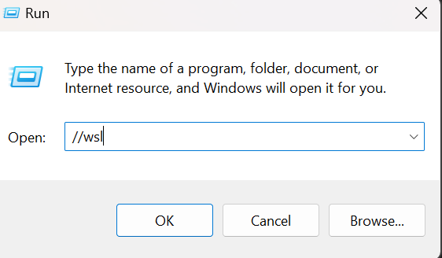

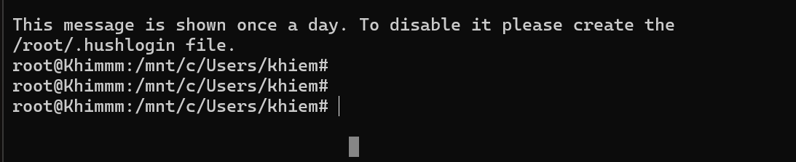

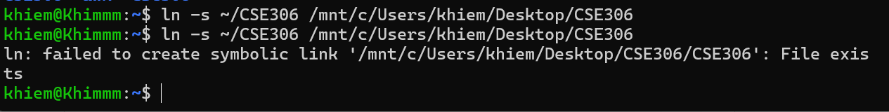

**3. Use ls command to list all files and folder in a specified path.**

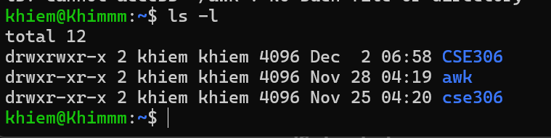

**4. Create a file named Grade.txt (using nano command) in CSE306 folder with the**

**following content:**

**Hai 6 5**

**Minh 7 9**

**Huynh 10 8**

**Ngoc 7 9**

**Ngan 4 8**

Go into the file : nano ~/CSE306/Grade.txt\

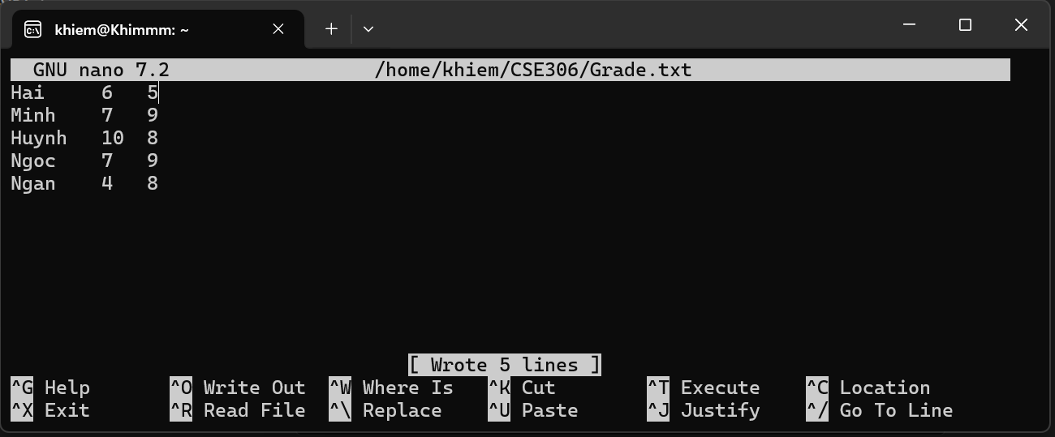

Show file: cat ~/CSE306/Grade.txt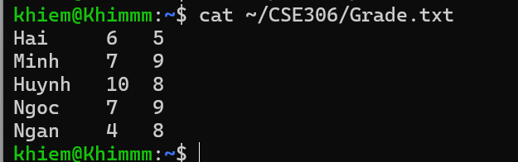

**5. Rename Grate.txt to StudentList.txt**

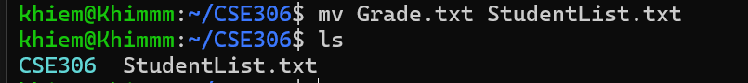

**6. Use sort command to sort the list by name column in descending order**

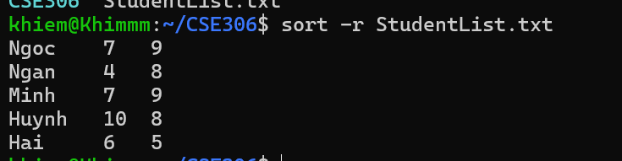

**7. Write a script to calculate the sum of two numbers entered by a user. (two ways)**

Using read:

Create file sh:

khiem@Khimmm:~/CSE306$ nano Sum2numbers.sh  


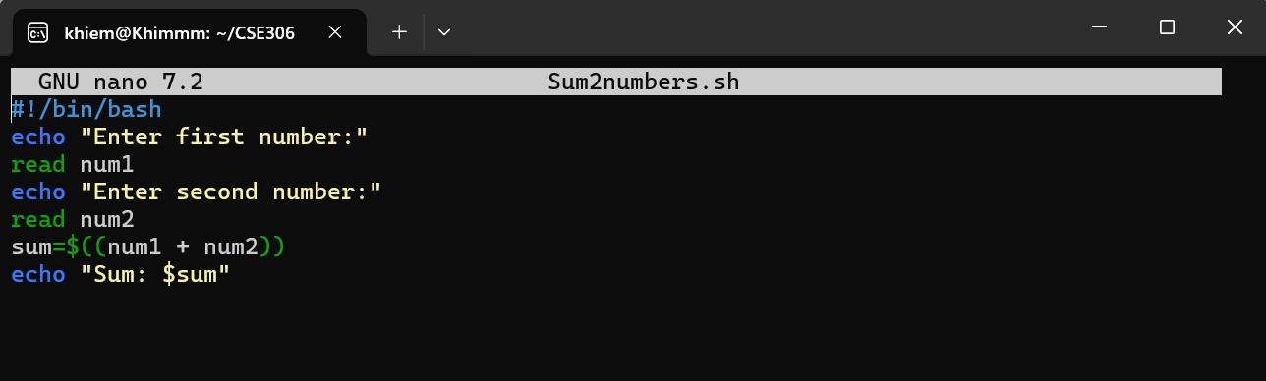

Run as:

khiem@Khimmm:~/CSE306$ chmod +x Sum2numbers.sh

khiem@Khimmm:~/CSE306$ ./Sum2numbers.sh

or: bash file_name.sh

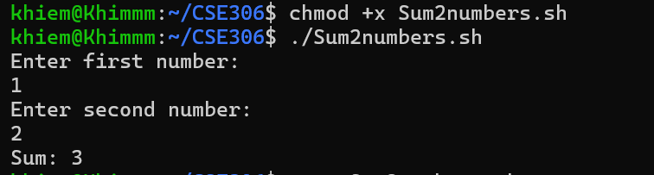

Using arguments:



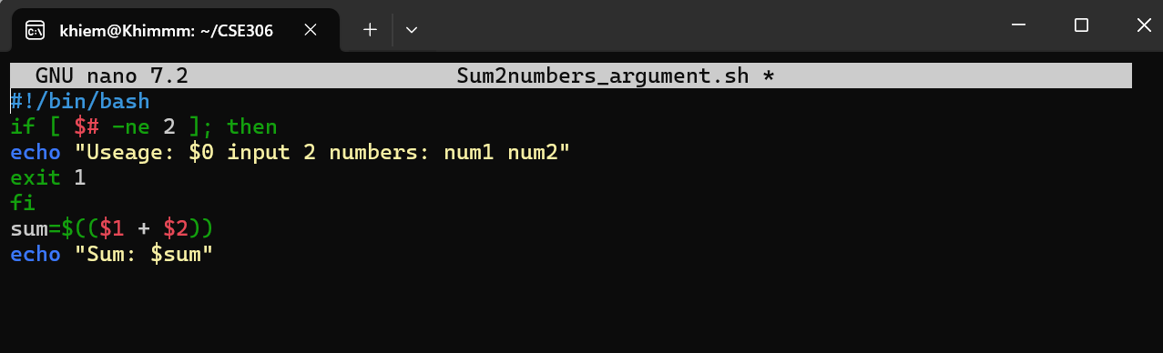

Run as:

khiem@Khimmm:~/CSE306$ chmod +x Sum2numbers_argument.sh

khiem@Khimmm:~/CSE306$ ./Sum2numbers_argument.sh 5 7

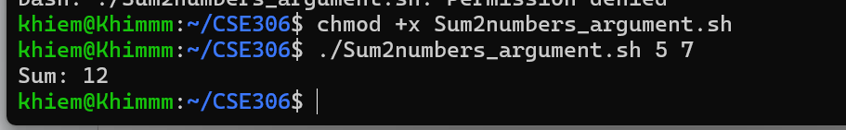

**8. Write a script that allows a user add a new student with grade to the list.**



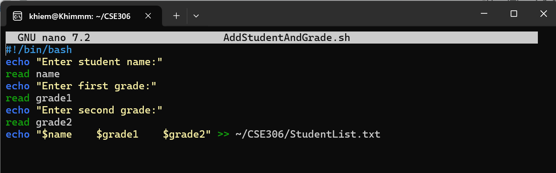

**Run & Check:**

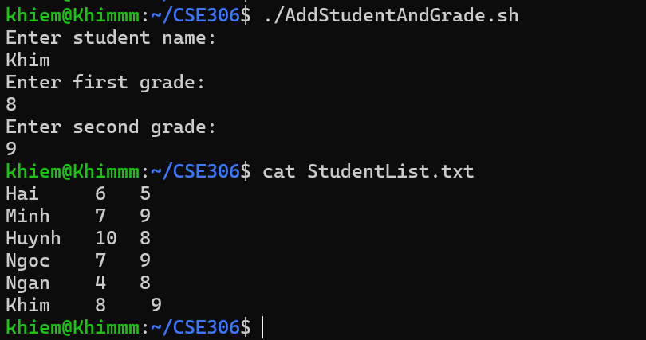

**9. Write a script for printing all files and folders in the present working directory.**



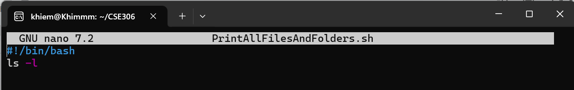

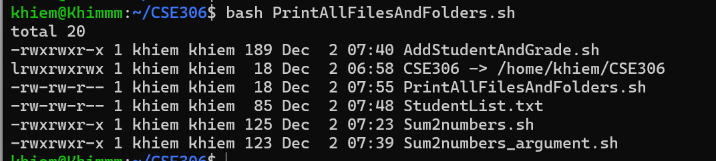

**10. Write a script for printing all files and folders in a specified directory and write to a log file.**

create a txt file





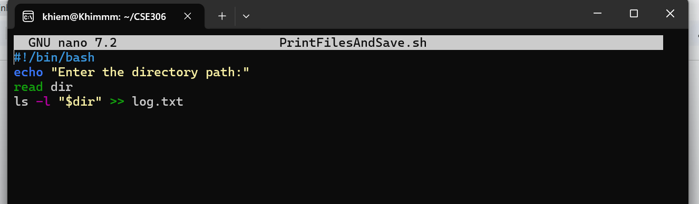

Run & Check:

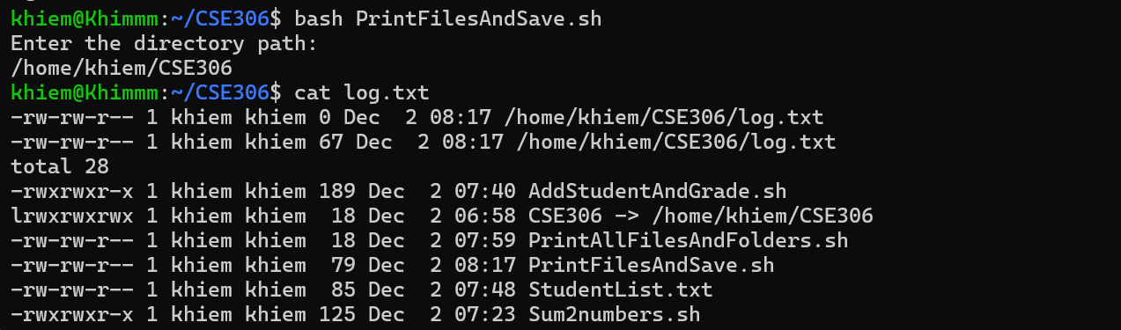

**11. Write a script for printing all executable files in specified directory.**

#!/bin/bash

# Prompt user to enter a directory path

echo "Enter the directory path:"

read dir

# Check if the directory exists

if [ -d "$dir" ]; then

echo "Executable files in the directory:"

# Find all executable files (-type f -executable) and print their names

find "$dir" -type f -executable

else

echo "The specified path is not a valid directory."

fi

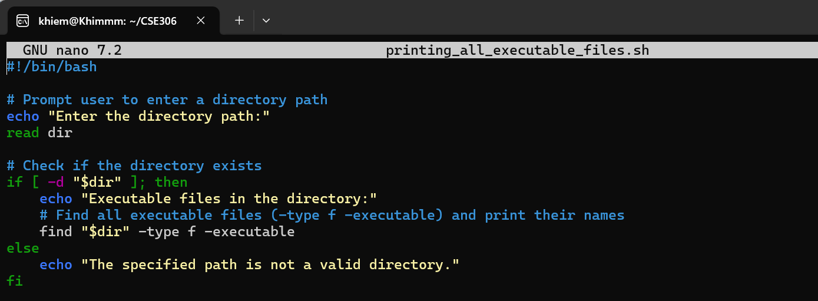

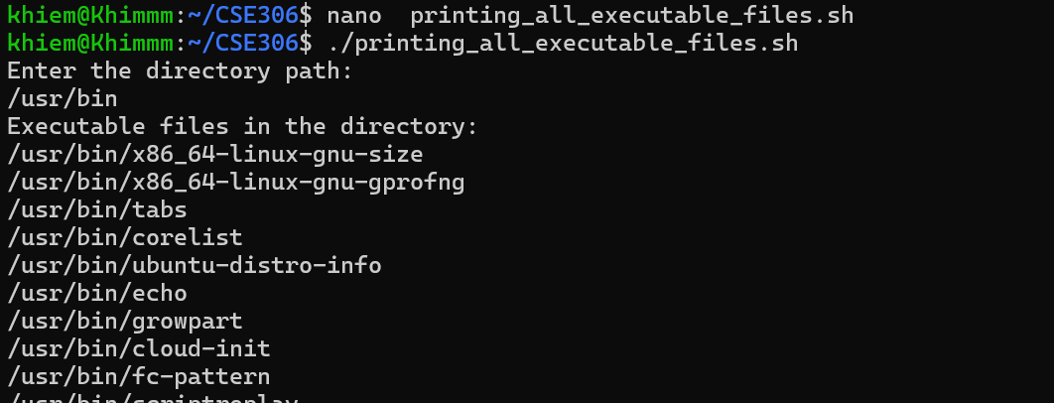

**12. Write a script to search a user present in your system. (use grep command) (*)**

#!/bin/bash

echo "Enter username to search:"

read username

grep "^$username" /etc/passwd && echo "User exists" || echo "User not found"

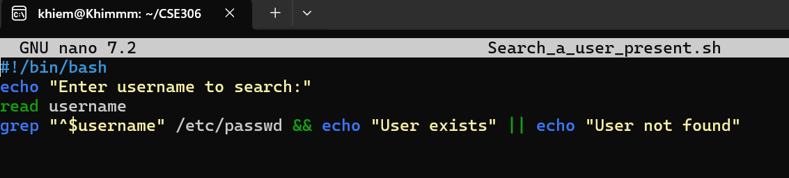

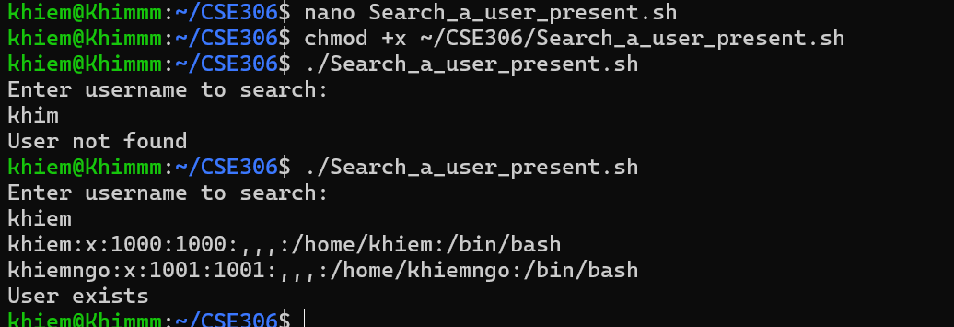

**13. Write a script to check if the file “file_path” exists and is writable.**

#!/bin/bash

echo "Enter file path:"

read file

if [ -w "$file" ]; then

echo "File exists and is writable"

else

echo "File does not exist or is not writable"

fi

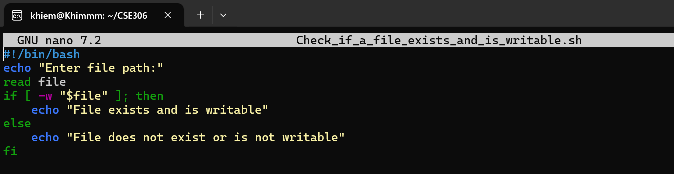



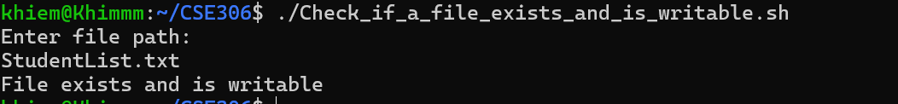

**14. Write a script that prompts the user for a path of a file or directory and return if it is a regular file, a directory, or another type of file. Also perform an ls command against the file or directory with the long listing option**

#!/bin/bash

echo "Enter file/directory path:"

read path

if [ -f "$path" ]; then

echo "It is a file."

elif [ -d "$path" ]; then

echo "It is a directory."

else

echo "It is another type."

fi

ls -l $path

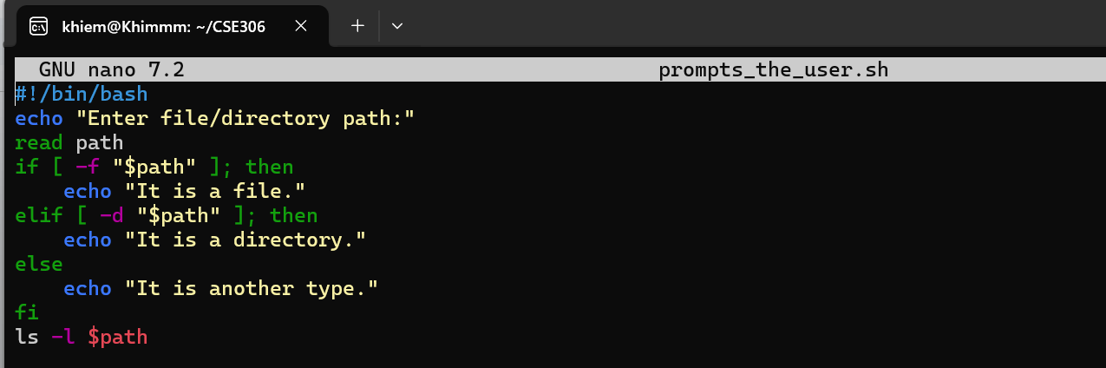

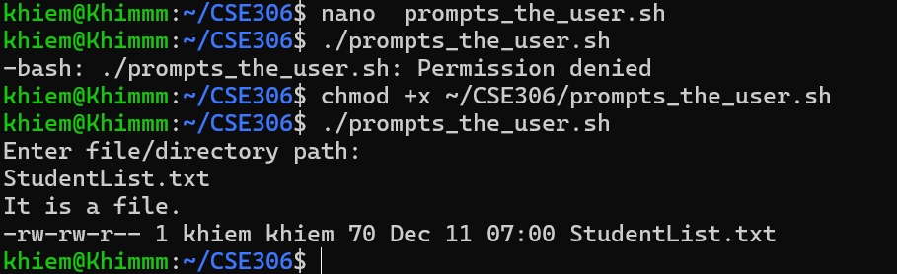

**15. Modify the previous script to that it accepts the file or directory name as an argument instead of prompting the user to enter it.**

#!/bin/bash

if [ $# -eq 0 ]; then

echo "Usage: $0 path"

exit 1

fi

path=$1

if [ -f "$path" ]; then

echo "It is a file."

elif [ -d "$path" ]; then

echo "It is a directory."

else

echo "It is another type."

fi

ls -l $path

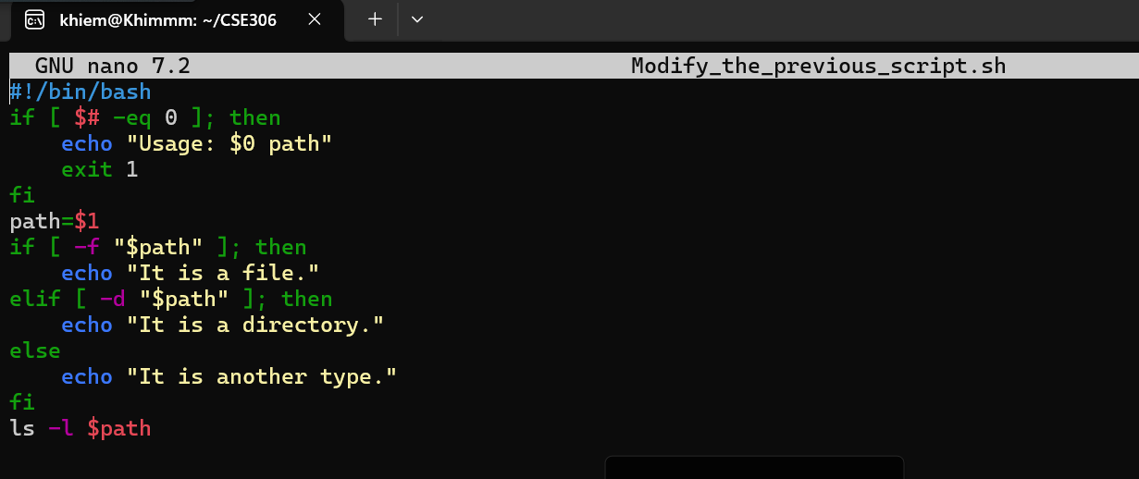



**16. Modify the previous script to accept an unlimited number of files and directories as arguments. (*)**

#!/bin/bash

for path in "$@"; do

echo "Processing: $path"

if [ -f "$path" ]; then

echo "It is a file."

elif [ -d "$path" ]; then

echo "It is a directory."

else

echo "It is another type."

fi

ls -l $path

done

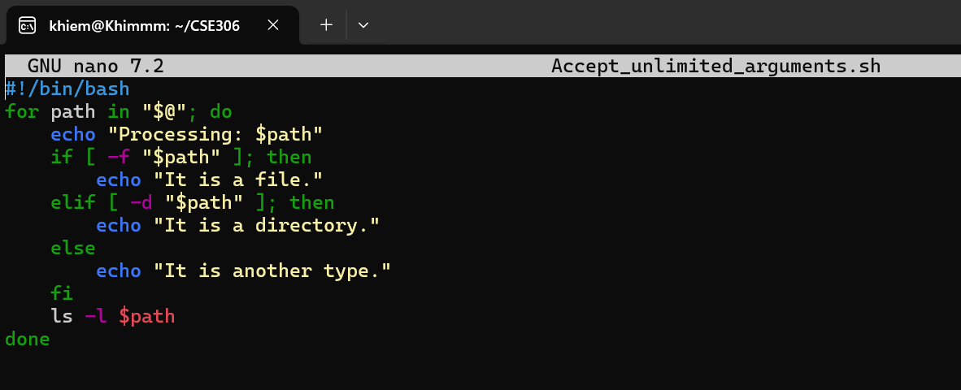

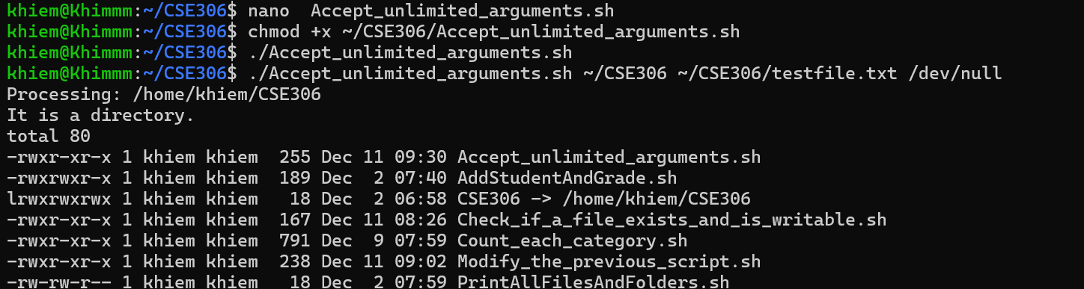

**17. Compress all scripts using tar command.**

tar -czvf scripts.tar.gz *.sh

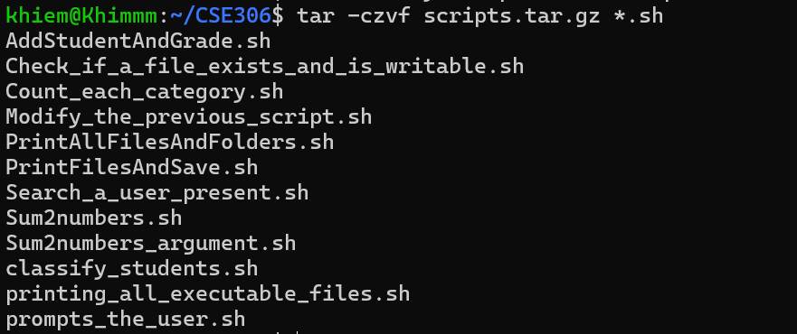

**18. Write a script that accept a string from a user and do the corresponding tasks:**

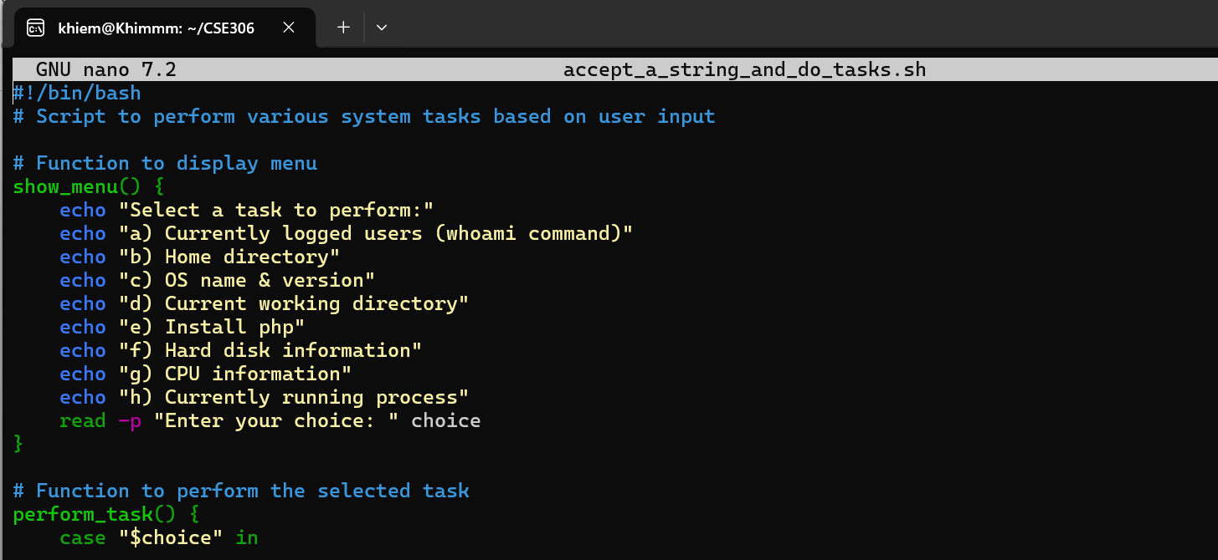

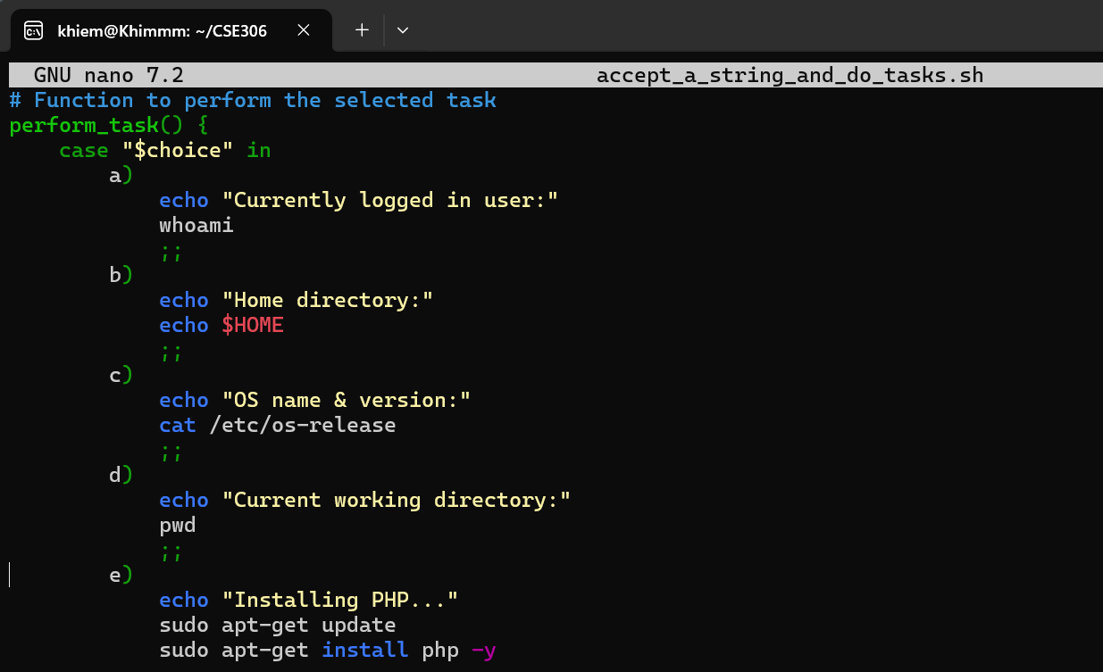

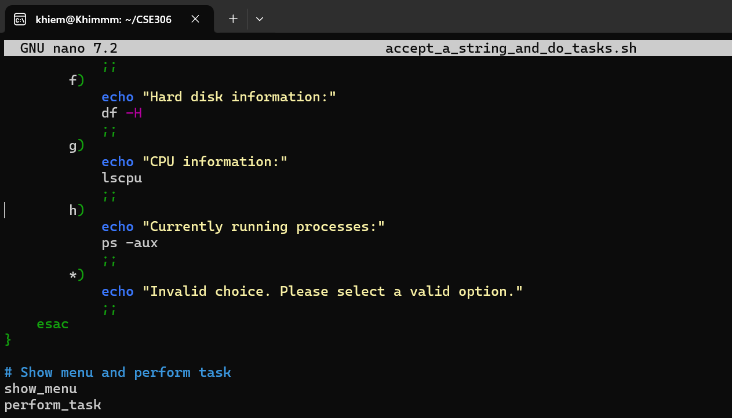

**Results**

**a) Currently logged users (whoami command)**

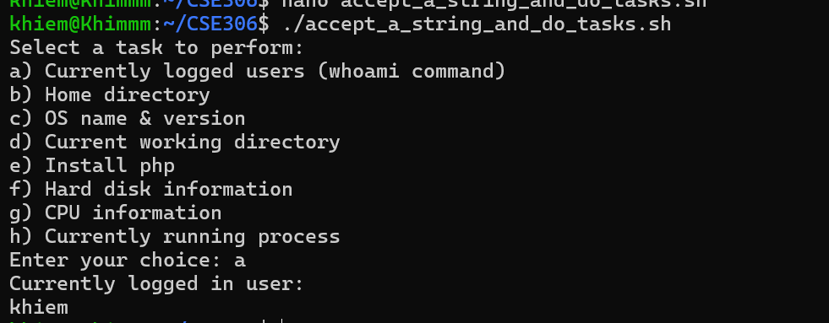

**b) Home directory (Find the variable to show the folder in TOP 25 Environment variables)**

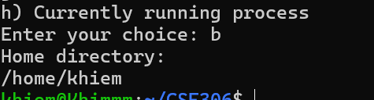

**c) OS name & version (cat /etc/os-release or hostnamectl)**

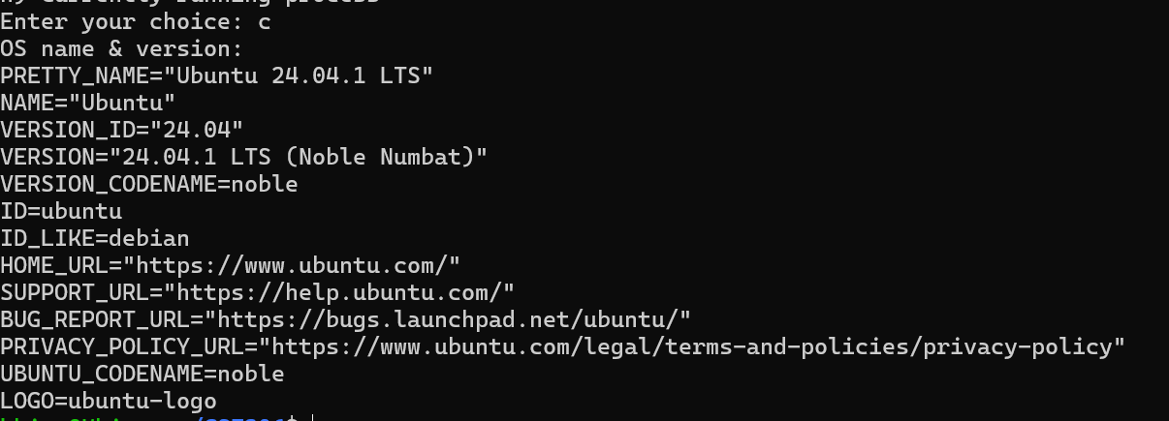

**d) Current working directory**



**e) Install php**

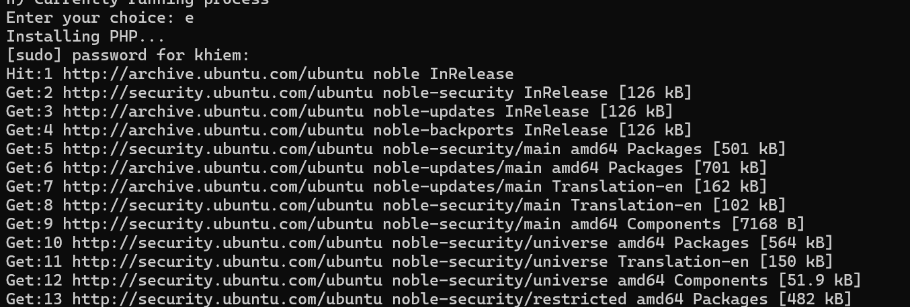

**f) Hard disk information (df -H)**

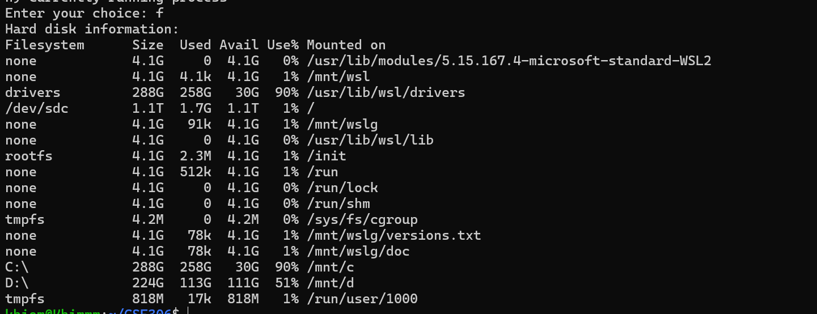

**g) CPU information (lscpu or cat /proc/cpuinfo)**

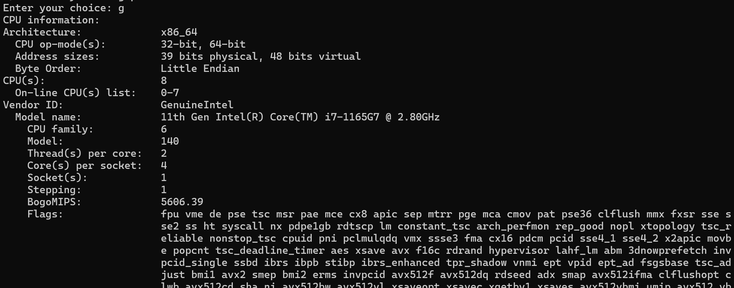

**h) Currently running process (ps -aux)**

